***Changes to the Diagram***

***Context***

Some of the main changes that have been made to the context diagram have been, customer. The customer entity has been combined into one, rather than having different types of customer entities we have a whole entity created. This will have it easier to arrange the different customers and since we are in the development of the database, it’s simply a drop down list for the different types of customers to make things simpler to arrange and populate.

Next will be the referee, the referee entity was added because someone has to record the score for each match that takes place. We decided as a group that this would be the best option since a score has to come from somewhere and someone has to keep an eye on each match that takes place. The referee will be enquired by the business owners, being a few referees to choose from so someone is always available.

The maintenance wasn’t really changed, there wasn’t a lot that could be changed or needed to be changed for the diagrams. This was because maintenance is an easy enough concept. This includes the suppliers again there wasn’t much that needed to be changed.

The new entity football team was added for the league, each team will be part of a league where the scores will be given from the referee to determine the placement of the team within the league table. We decided to add in the football league because it was something Campsie has recently added, we thought it would be a good idea to help them out as much as possible to make life easier for the workers.

NEW SYSTEM

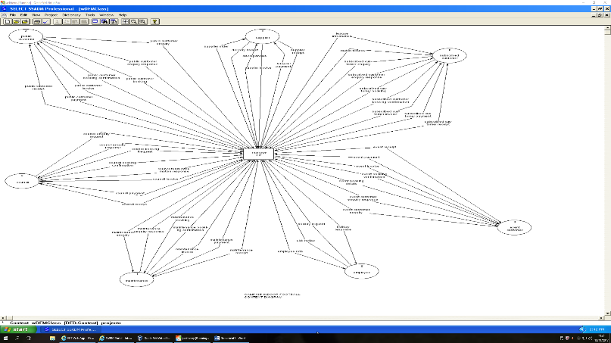

CURRENT SYSTEM

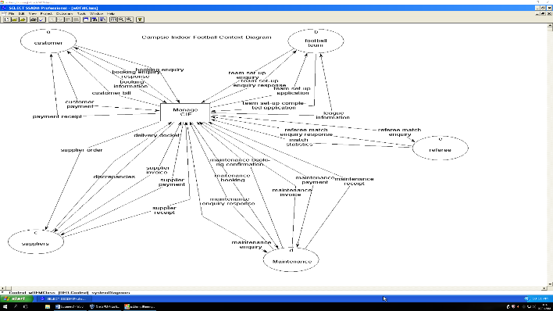

2 Entities have been removed and even though there are less data flows, there is actually an increase of data being inputted into Campsie Football Indoors system. Naming conventions have been change to improve readability

***Level 1/2/3***

The diagram for the level was, the amount of data flows coming to and from the entities has greatly decreased. This is due to the more refined and specific needs of the user. We felt as though less was more in this case because going down through the depths this an example of us starting to meet specific needs and looking and what the user also needs rather than wants. Reducing the data on the tables and normalising the tables allowed us to reduce the overall size of the system and make it less complex. The main changes from the current system is that all of the data in the data flows are being stored inside a Data-store not a manual-store. This is the main improvement with the system we are making because if all of the information is being stored on the system then it will make it a lot easier to manage and handle instead of using a manual store method. Also if data is available on the system then reports and forms can be made for the data meaning it can be managed and displayed easier. This also future proofs the system.

NEW SYSTEM

CURRENT SYSTEM

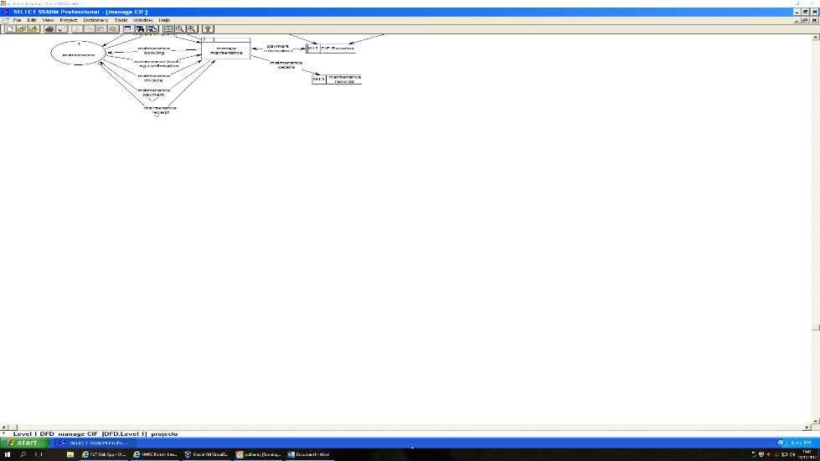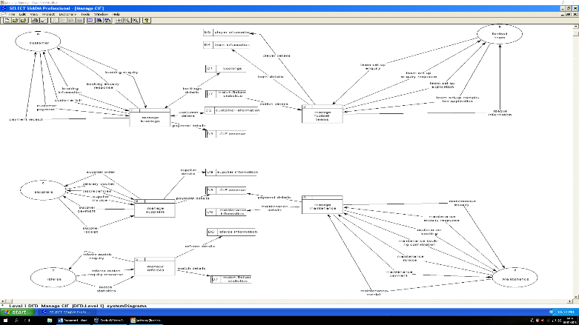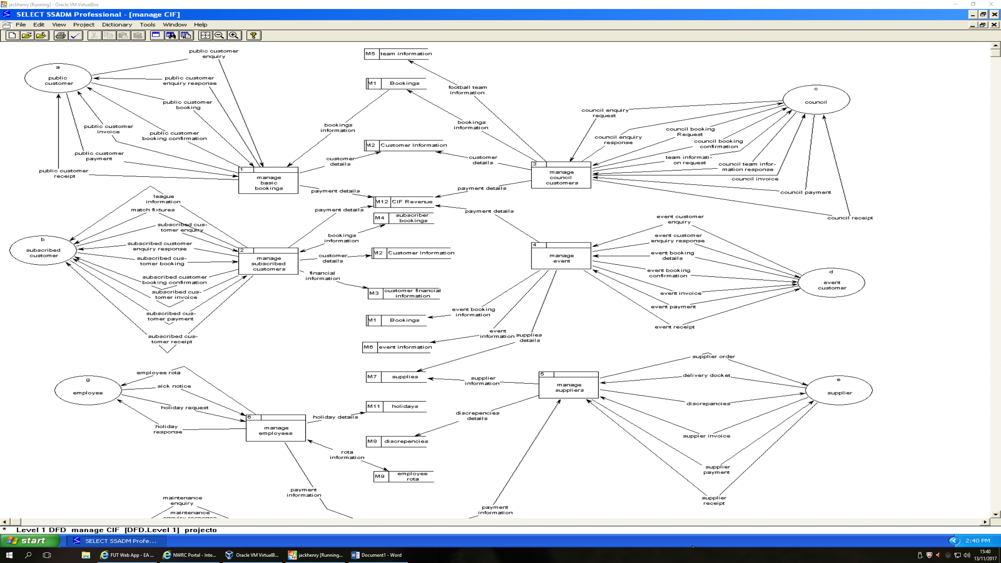

Having less entities means that the level 1 diagram looks even more coherent. The level 2s and 3s are almost identical but except for the implementation of the league table with brings new data stores and forms. They have the same amount of data flows except data-stores and used instead of manual-stores. Level 4s were not needed in the implementation of the new system

Inputs

Football Team

* Team set-up enquiry

A football team of organisation will make an enquiry into whether or not they can join the league system within Campsie Indoor Football.

* Team set-up completed application

Information pertaining to the specific team which will contain the team name, team logo, as well as information about their players such as their name and age.

Maintenance

* Maintenance Enquiry Response

After we make an enquiry to a certain maintenance company, they will then respond to us detailing whether they can fulfil our original request of not. Details about cost and stock will also be provided.

* Maintenance Booking Confirmation

Once they have responded and CIF decides to book maintenance then they will confirm whether or not they can complete the booking at the specified time and place.

* Maintenance Invoice

The maintenance company will then provide CIF with an invoice detailing the services provided as well as a total sum or price of the maintenance.

* Maintenance Receipt

After the invoice has been the maintenance company will then provide CIF with a receipt detailing the maintenance carried out and a statement that it has been completed.

Referee

* Referee Match Enquiry Response

Once we have made an enquiry to a referee or refereeing body then they will reply to us detailing whether or not they can fulfil our request and referee the game or games requested.

* Match Statistics

After the referee has completed the game, they will then provide us with all the match statistics and information so that we can store it and use it to create reports or information about the team such as yellow/red cards, goals and injuries.

Suppliers

* Delivery Docket

This will come accompanying the delivery that we receive which will detail the goods delivered, such as price and quantity. A copy of it will be sent back to the supplier and another copy will be kept by CIF once signed.

* Supplier Invoice

This will be provided by the supplier which will detail the items that have been delivered along with a statement of the total price.

* Supplier Receipt

Once the supplier has provided a receipt of the delivery, they will then provide CIF with a receipt which will detail the delivery and a statement that it has been completed.

Customer

* Booking Enquiry

A customer will make a booking enquiry when they wish to make a booking to play indoor football. They will get in contact through a phone call or text message to enquire if a desired time and date is available. CIF would get in contact soon after.

* Booking Information

Once CIF replies to the customer’s enquiry, the customer will then detail the exact details of their booking such as time and date as well as any other special requirements.

* Customer Payment

After the customer has completed their session, they will then pay the bill that CIF sent out to them, this will detail the payment method and amount they are to pay.

Outputs

Football Team

* Team set-up Enquiry Response

Once CIF have received the enquiry from the team or organisation, which wish to join the CIF indoor football league, then they will respond to the team or organisation informing them if they are eligible to play within the league and other information about the league, as well as detailing the application process.

* Team set-up application

This will be sent out to the team or organisation, it will be an application form which will ask the team to complete detailing all important information such as team name, team logo and information about their players such as name and age.

* League Information

This will contain information about the league, it will contain the table information, other teams within the league, fixture date and times and the location of the game.

Maintenance

* Maintenance Enquiry

This will be an enquiry that CIF will make to an external maintenance company about the specific maintenance that needs to be carried out. This will detail what needs to be done and request the services of the maintenance company.

* Maintenance Booking

Once the maintenance company have responded to the enquiry and said whether or not they are willing to provide their services, CIF will then make a booking for the maintenance company.

* Maintenance Payment

Once the maintenance has been completed to the satisfaction of CIF then the maintenance company will provide an invoice detailing it. After this CIF will make a payment to the maintenance company for their services.

Referee

* Referee Match Enquiry

This will be an enquiry that CIF will make to an external referee or refereeing body requesting their services for specific games. This enquiry will be done to discover whether or not the time is suitable for the referees.

Suppliers

* Supplier Order

This will be an order that CIF will place with an external supplies company. This order will detail exactly what the company needs in terms of stock.

* Discrepancies

This will be feedback that CIF will provide the supplier company with based on the delivery, it will detail any problems with the delivery whether there was an item of stock that was not delivered or if more than expected of a certain item was delivered.

* Supplier Payment

Once the delivery is completed and an invoice has been provided to CIF, a payment will be made to the supplier company from CIF of the amount owed.

Customer

* Booking Enquiry Response

Once a customer has made an enquiry to CIF, a response will be provided based on their enquiry detailing whether they can fulfil the booking at the requested time or not.

* Customer Bill

Once the Booking has been placed and the customer has attended their indoor football, they will be billed with an invoice detailing exactly how much they have to pay for the session or sessions.

* Payment Receipt

Once the payment has been made from the customer to CIF then they will be provided with a receipt detailing their session length and time as well as acknowledgement that the payment has been received.

FILES

Player Information

* This will be where all of the player information stored and recorded. It will then be used to connect the players within the teams. This information will be retrieved from the team set-up forms for registration, however, players can be added separately if needs be.

Team Information

* The team information will be stored in its own table and will retrieved from the team set-up forms that have been given by the players.

Bookings

* A record of all the bookings will be recorded and this will allow for complex reports to be made of the bookings and allow the users to get an insight of the booking performance

Match Fixtures

* Match fixtures will be automatically generated within the system and stored in a file. The league table will depend heavily on what teams have been selected by the user for the league.

League

* The league table will stored a record of all the team performance within the match statistics file and create a league table based off of the information stored within the file. The league information will also store the league name

CIF Revenue

* All bookings will be recorded on a payment table and this will then update the payment records whilst generating a total revenue made

Suppliers

* Within the supplier file the users will be able to add new suppliers along with the products connected to that supplier meaning that stock checks can be reported on. It will be connected to the CIF Revenue file

Referees

* For league games referees will be needed to create a match card that will then be given to the user to update the match statistics. The referees will be stored in a separate file

Processes

Manage Booking

* All of the data that the users will be inputting into the system will most of the time be giving through the phone by the customer. The user will ask for all of the information needed to complete a booking and if the customer is new then the customer will have to complete a registration process that will keep a record of the customer’s payment and contact details. If the booking time is not suitable then the user will suggest a different time that the booking can take place. When the booking is completed it will then be stored in a file.

Manage Football Teams

* When a new league is about to take place customer will be notified and will then be able to take a sheet with the team details and fill out the players that will be participating in that league. Once a certain date is reached the user will then take the forms and fill the teams into the files. Customers can also apply to be part of the league and sign for the free agents meaning that if a team is in need of players or changes need to be made then that player will be called.

Manage Maintenance

* This process has stayed mostly the same from the previous system. The user will call to schedule a specific type of maintenance that is required for the pitch. They will then book the maintenance in a time slot that is widely free and then after the maintenance is completed the maintenance worker will be paid and this will be recorded in the CIF revenue file.

Manage Suppliers

* CIF still needs regular stock checks to be made as they go through a lot of equipment each day. A record of all of the suppliers and products will be kept and users will be able to add new suppliers and connected the products with it allows for reports to made of all of the stock that has been brought. It is an input and output process as stock will be managed and brought in.

Manage Referees

* The user can phone the council and enquire about the different referees available for coaching and contact them. New referees can be added to the system and be used for league matches that take place. All of the referee information will be record such as the name and contact information. The user can then use this contact information see if the referee is available for a specific match or league match. The referee will carry a match card during the game and record the final score of each team and then give that to the user, allowing them to update the match statistics with the card that was giving